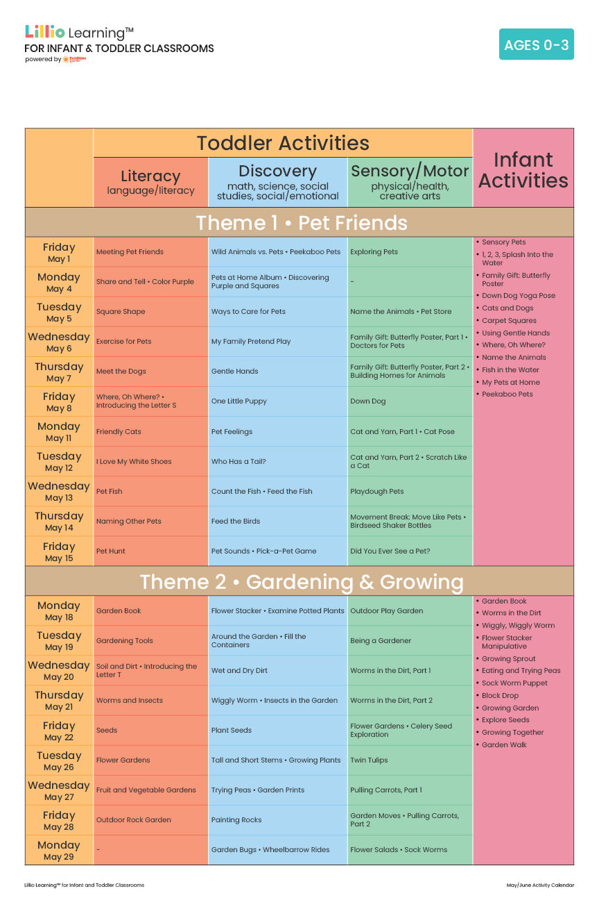
Add Your Name/Logo Here
May 2026
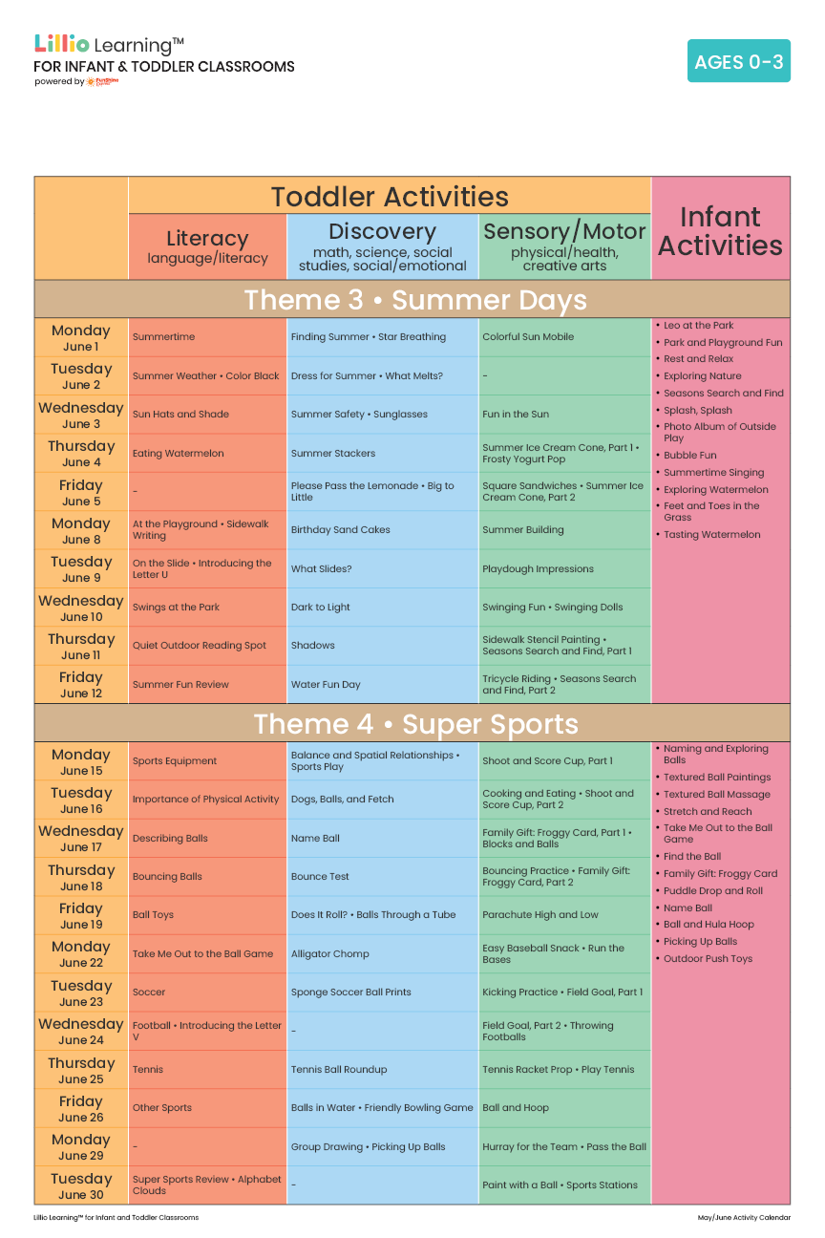
Add Your Name/Logo Here
June 2026

